A1 assignment
- The circuit schematic design:
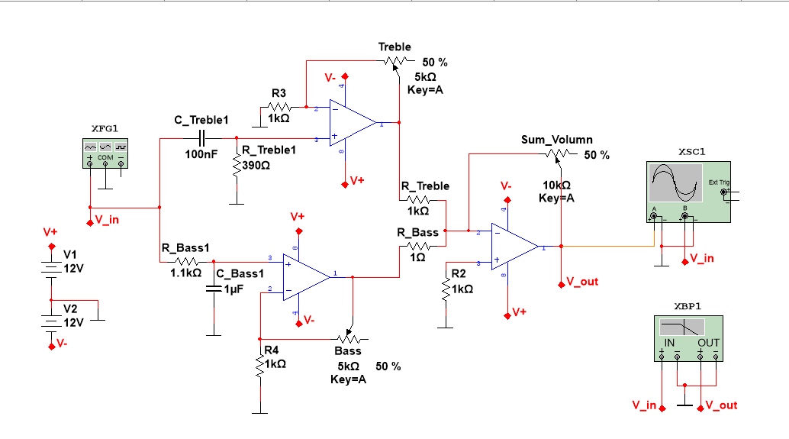
- Frequency response graphs from the simulation:
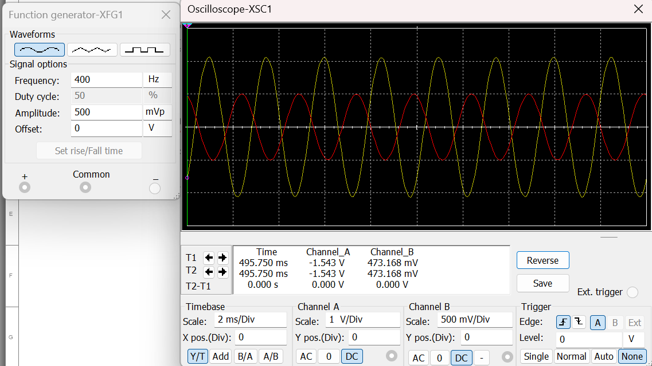
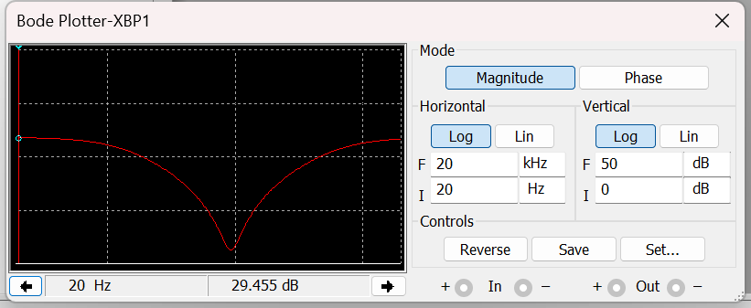
- Relevant measurement results:
- Rcomp = 500 Ohm: To matching impedances at both inputs (two 1k Ohm parallel) in order to minimizes the impact of noises on the op amp.
- F_{cutoff} = $\frac{1}{2π R C}$ = $\frac{1}{2π . 1100 . {10}^{-6}}=145 Hz$ (Bass is around 100 - 200 Hz typically)
- F_{cutoff} = $\frac{1}{2π R C}$ = $\frac{1}{2π . 390 . {10}^{-5}}=4080 Hz$ (Treble is around 4kHz)
- Gain: A = $1+ \frac{R_{f}}{R_{in}}=1+ \frac{10 k}{1 k}=11$
- A _{sum} =- $\frac{R_{f}}{R_{in}}= - \frac{10 k}{500 }=-20$
Breadboard
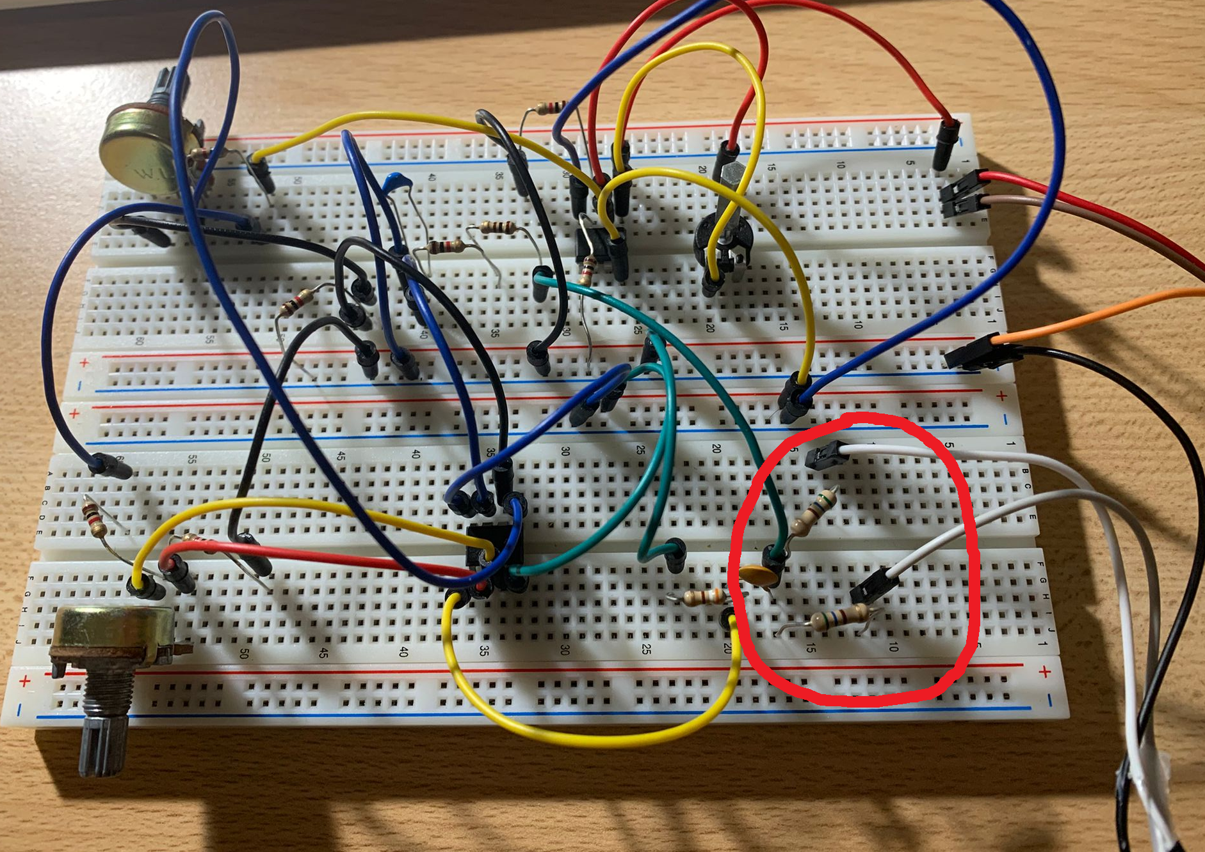

- At the image above, we have split the left and right channel of the input signal (music) into 2 resistor of 560 Ohm, before joining them and feed to the filters. This will prevent any backward shot from one channel to the other when the filter resistor is too large.
- However, we still have not figured out how to cancel out the noises created by the AC power source that are fed to the op-amps, which reduce the output quality .

Nguyen Hoang | 566422

